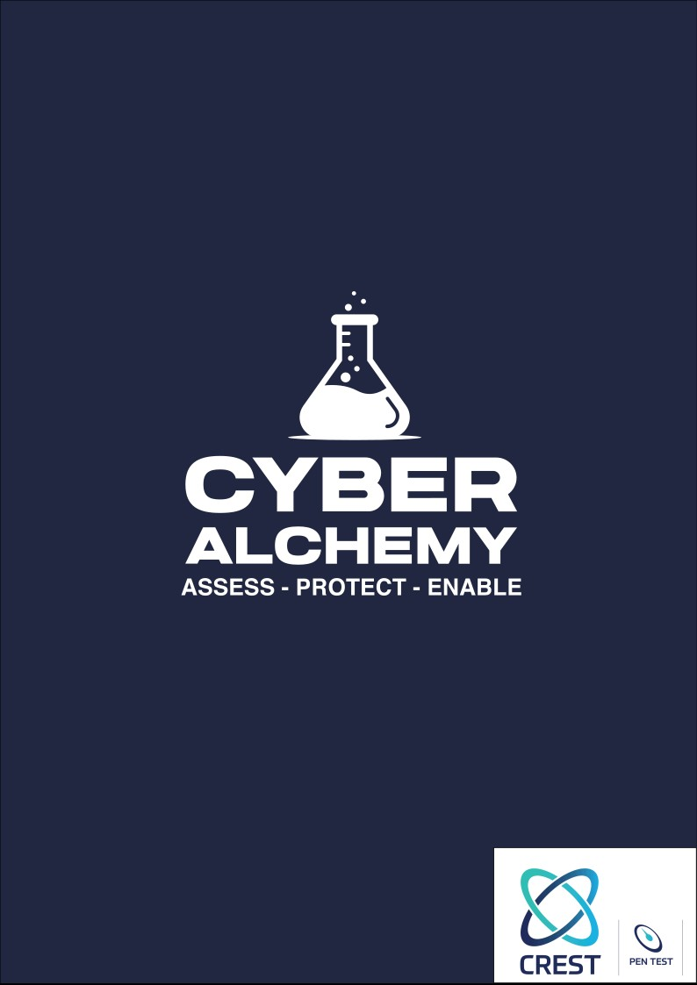

Web Application Scoping

Web Application Scoping

Provide company name, your name, email and job title.
Company Name:
Your Name:
Email Address:
Job Title:
Provide your company name, your name, corporate email address and job title.

What is the name of the application, and what is its purpose?
Application Name:
Application Purpose:

Provide a brief description of the application.

Provide all the URLs in the scope of the assessment.
All URLs provided here will be included in the scope of the assessment.

How many different user roles exist in the application? Which of these roles need to be tested, all roles or specific ones (please list)
The user roles could be Admin, User, HR etc. Provide all the user roles and the roles you would like us to test.

Does the application support multiple tenants, where different organisations have separate, self-contained client areas (e.g., Organisation A and Organisation B each have their own distinct client portals)
In addition, if the application has multiple tenants, include details about any shared functionality between the different tenants.

How many static and dynamic pages does the application have?
A static web page displays fixed content that remains the same for all users, while a dynamic web page generates content dynamically based on user interactions, databases, or server-side processing.

Describe key aspects of the functionality of the application.
Provide a list of key aspects of the application like, user registration, file uploads and payment integrations.

Does the application have an API? If yes, how many API endpoints?
Provide the total number of API endpoints that you would like to be tested.

What are the primary business objectives driving this test? (e.g. compliance, yearly security assessment)

Is there a date on which the testing must be completed? If yes, provide the date.

Is there anything else you would like us to know?

Cyber Security Assessment Process
 | Scoping Document Completion  The first step involves completing the scoping document. This document will help us understand your systems, applications, and objectives. It outlines the areas that need to be assessed and ensures we capture all essential information to deliver a thorough and accurate cybersecurity assessment.
 | Scoping Call (If Required)  If further clarification is needed, we will arrange a scoping call. We recommend having application developers present to address technical questions and provide insights. During the call, we also request a live demonstration of the application to better understand its functionality and potential areas of risk.
 | Proposal Submission  Based on the scoping document and any additional information gathered during the scoping call, we will provide a formal proposal. This outlines the scope of the assessment, including what is in and out of scope, the estimated duration of testing, and the associated costs. This ensures full transparency and alignment before the assessment begins.
 | Project Management  Once the proposal is accepted, we initiate project planning to ensure the assessment is delivered on time and meets your internal deadlines. We will coordinate with you to schedule the assessment, define key milestones, and identify any dependencies. Our team will maintain clear communication throughout the project, ensuring expectations are aligned and any logistical or technical challenges are addressed promptly.
 | Cybersecurity Assessment  When the project plan is in place, our experienced cybersecurity professionals will conduct the assessment. Using industry-recognised standards and our proprietary Cyber Alchemy methodology, we thoroughly evaluate your systems to identify vulnerabilities and assess risks. Throughout the assessment, our consultants will provide regular updates on progress and promptly report any critical issues or concerns. This ensures you remain informed and can address urgent matters without delay.
 | Report Delivery  Upon completion of the assessment, we compile a comprehensive report. This includes a management summary, detailed findings with CVSS scores, likelihood and potential impact of exploitation, proof of concept for critical vulnerabilities, and clear mitigation steps. This report serves as a valuable resource for both technical and non-technical stakeholders.
 | Post-Assessment Review  We offer a post-assessment review meeting to walk you through the report. This session allows your team to ask questions, clarify findings, and understand exploitation methods and mitigation strategies. Our goal is to ensure your developers can address vulnerabilities effectively and avoid similar issues in the future.

Web Application Assessment Methodology
Approach:
Web application assessments can be performed either remotely or on-site, depending on the application’s exposure. The assessment aims to identify any vulnerabilities that can be exploited to attack the system or other users, bypass controls, escalate privileges, or extract sensitive data. The consultants will use proven non-invasive testing techniques during the assessment to identify any weaknesses quickly. The application is viewed and manipulated from several perspectives, including with no credentials, user credentials, and privileged user credentials.
Cyber Alchemy’s web application testing methodology covers the OWASP Top Ten standard, representing a broad consensus about the most critical security risks to web applications. The OWASP Top Ten for 2021 is as follows:
- A01:2021-Broken Access
- A02:2021-Cryptographic Failures
- A03:2021-Injection
- A04:2021-Insecure Design
- A05:2021-Security Misconfiguration
- A06:2021-Vulnerable and Outdated Components
- A07:2021-Identification and Authentication Failures
- A08:2021-Software and Data Integrity Failures
- A09:2021-Security Logging and Monitoring Failures
- A10:2021-Server-Side Request Forgery

Methodology:
The first step of the engagement is to set primary contacts on both sides, define the testing objectives and set the context. From this, a bespoke approach can be crafted to extract the maximum amount of value from the engagement. Once this has been done, Cyber Alchemy will begin the assessment, covering the following categories of the OWASP testing guide v4.2. Examples of the type of testing and its objectives are given for each category. Specific testing will depend on the technology and protocols implemented and the testing objectives.
Information Gathering
- Open Source INTelligence (OSINT) reconnaissance of the system.
- Fingerprinting the technologies in use by the web server and web application.
- Mapping the application architecture.

Configuration and Deployment Management Testing
- Test the configuration of the network infrastructure and application platforms.
- Test the HTTP methods (verbs) that are implemented.
- Discover sensitive information from unreferenced and hidden files.
- Test for subdomain takeover.
- Establish if cloud storage, such as AWS S3 or Azure Blob, is implemented, and if so, we will test for vulnerabilities in the implementation.
Identity Management Testing
- Testing for account role definitions, in line with best practices such as the principle of least privilege.
- Account enumeration through functions such as the login or account.
- Testing that the applications utilise a secure username policy.
- Testing the user registration and account provisioning processes.

Authentication Testing
- Find possible brute-force password guessing vectors in the application.
- Find valid login credentials with password grinding.
- Assess the lockout policy for failed attempts.
- Determine the application logic to maintain authentication sessions, such as the number of failures, logins allowed, and login timeouts.
- Assess the password policy and any other authentication functions.
- Determine the limitations of access control in the applications – access permissions, login session duration, and idle duration.

Authorisation Testing
- Testing for directory traversal file inclusion.
- Testing for bypassing authorisation schema.
- Testing for privilege escalation.
- Testing for insecure direct object references.

Session Management Testing
- Testing to ensure session information is protected through cookie attributes and other measures.
- Testing session timeout and logout functionality.
- Testing for session hijacking, session puzzling and session fixation.
- Testing for Cross-Site Request Forgery.

Input Validation Testing
- Testing for stored and reflected Cross-Site Scripting (XSS) vulnerabilities.
- Testing for SQL Injection.
- Testing for HTTP verb tampering and parameter pollution.
- Testing for technology-specific injection vectors, such as LDAP, IMAP and SMTP injection.
- Testing for XML and Xpath Injection.
- Testing for HTTP splitting and smuggling vulnerabilities.
- Testing for Host header injection.
- Testing for Server-side template injection.
- Testing for Server-side request forgery.

Testing for Error Handling
- Testing for improper error handling.
- Testing for stack traces.

Testing for Weak Cryptography
- Ensuring all areas of the system are protected by strong cryptography, in line with any compliance requirements the system might have.

Business Logic Testing
- Testing the application based on the context and expected functionality to uncover issues that could allow an attacker to impact the organisation. This could be through areas such as;
  - Application Misuse
  - Circumventing workflows
  - Bypassing integrity check
- Testing the business logic inputs for semantic and syntax correctness.
- Testing for vulnerable file uploads that could, such as uploading a malicious file or file types.

Client-side Testing
- Testing for client-side injection attacks, such as DOM-Based Cross-Site Scripting (XSS) and HTML injection.
- Testing for Clickjacking
- Testing WebSockets implementation.
- Testing the Cross-Origin Resource Sharing (CORS) implementation.
- Testing Browser Storage is configured correctly and doesn’t contain unsecured secrets or could be leveraged to conduct an injection attack.

API Testing
- Testing any API integrations that the web application utilises, applying other areas of the OWASP WTSG to the API, as required.

